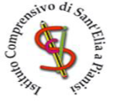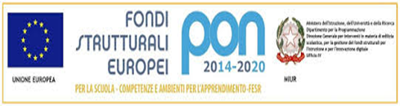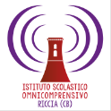
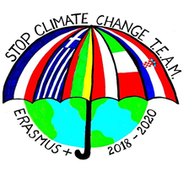
ISTITUTO OMNICOMPRENSIVO DEL FORTORE RICCIA – SANT’ELIA A PIANISI
27th January 2020
Erasmus Plus "Stop Climate Change - Together Europe achieves more"
POLISH MOBILITY – REPORT
This event offered the opportunity to talk about the forth meeting in Poland to all the students of our Institute and their families and to introduce them the Erasmus Plus project “INCLUSIVE STRATEGIES”, that will implement inclusive teaching methodologies.
THE STUDENTS WERE BRILLIANT AND COMPETENT PROTAGONISTS. We thank our Headmistress, the mayors of Sant’Elia a Pianisi, Pietracatella, Monacilioni, Macchia Val Fortore, students and families.

