 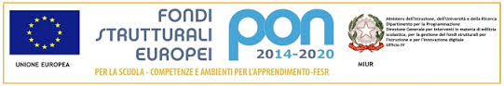 

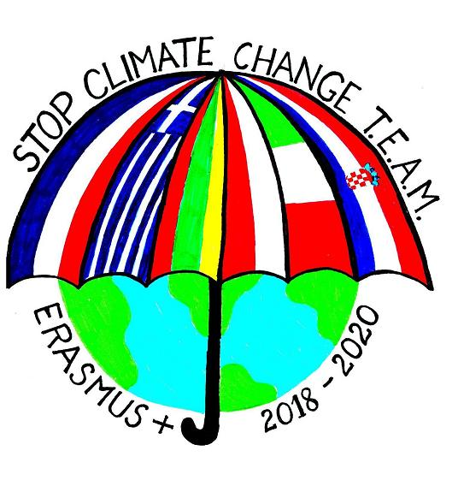

ISTITUTO OMNICOMPRENSIVO DEL FORTORE RICCIA – SANT’ELIA A PIANISI

Erasmus Plus " Stop Climate Change -Together Europe achieves more"

World cleanup day

21/09/2019

Some teachers and students of Pietracatella, a school of our Institute, took part at the *World Cleanup Day* on 21st September 2019, together with *Legambiente,* an Italian association linked to environmental issues. Around the world, participants of all ages and backgrounds tackled out-of-control waste, educated others on the perils of single-use plastic and encouraged individuals and governments to change behavior and policies regarding consumption and waste.

