Erasmus+ project 2018-2020
2018-1-HR01-KA229- 047516
Stop Climate Change – Together Europe Achieves More
LESSON PLAN
Lesson: No more bees
Teacher: Gordana Maršić
Time: 50 minutes
Level: lower intermediate, intermediate
Topic: environmental problems, climate change, disappearing of bees
Objectives: to develop reading and speaking skills, to discuss environmental issues,
to deal with cause/effect relationship, to deal with problems and suggest
solutions, learn how to form and use second conditional
Key words: environment, global warming, bees, pollinate, food, oxygen, diasppear
Outcomes: Students will be able to understand important causes of disappearing of bees,
and some solutions, explain why it is important to protect and save the bees
Languge skills: answering questions, expressing opinion, agreeing, disagreeing,
using second connditional
Required materials and equipment: blackboard, chalk, handouts with text, photos
Literature: Elaine Walker, Steve Elsworth: Grammar Practice for Intermediate
Students, Longman
Liz Kilbey: Discover English 4, Textbook, workbook, Pearson
Maja Lunde: Povijest pčela, Naklada Ljevak
Cross curricular element: biology
Student grouping: whole class, individual
NO MORE BEES
Describe the pictures. How are they connected? Discuss your ideas with the class.
1 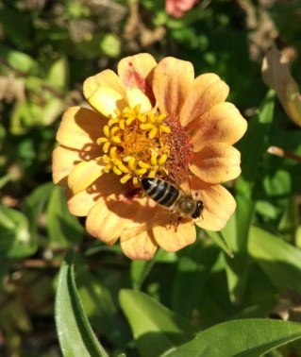 2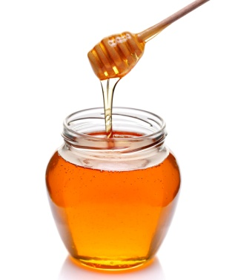 3 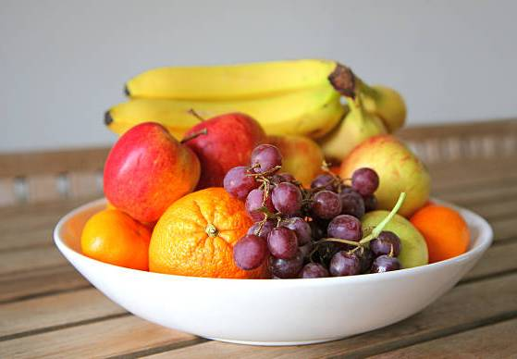
4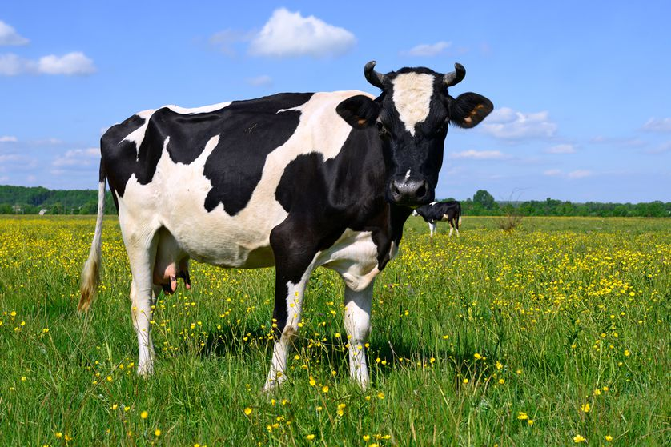 5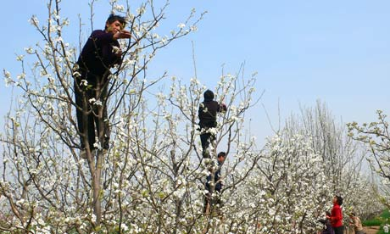
What would the world be like if there weren't any bees?
At first, everything would seem just the same, or perhaps even a bit better – there would be no more annoying little insects, and no more stings. Then we would start to notice some effects – for example, the shops would stop selling honey. Perhaps that doesn't sound too bad – we could all live without honey. But it wouldn't stop there. It would get a lot, lot worse.
There's a famous quotation, which some say is from Albert Einstein:
„If bees disappeared...man would have only four years of life left.“ It sounds crazy – but is it? We all know that bees carry pollen from flower to flower (they pollinate the flowers). These flowers are not just the flowers we see in florists' shops. They are also flowers on many other kinds of plants. Lots of our food comes from plants that depend on bees, including many types of fruit, vegetables, nuts and beans. If we didn't have bees, we wouldn't have cotton either – so no jeans or T-shirts. A lot of animals would also disappear – because bees pollinate their food. So there would be far less meat, and no milk or cheese. Imagine a cheeseburger – there would be nothing left except the bread. Even worse, we'd have no chocolate!
All over the world, people would be hungry and that would lead to a global war. But that's not all. It would actually become harder for us to breathe. That's because green plants produce oxygen. If they disappeared, there would be less oxygen.
So the Einstein „quotation“ might be close to the truth. „A world without bees“ would make a great horror film. Unfortunately, it's not just science fiction. Bees are dying in great numbers. Some scientists think it's because of the chemicals that farmers spray on their plants. Others think it's because of a virus – and some even believe it's because of mobile phones.
Lots of sceintists think that bees are dying because of climate change which is causing habitat loss for many bee colonies. Shifting temepratures are a big problem. As average temperatures rise, flowers bloom earlier in spring. It is a mismatch in timing between when flowers produce pollen and when bees are ready to feed on that pollen. Even a mismatch of three to six days could negatively
affect bees' health making them less resistant to predators, parasites and diseases.
So next time a bee is annoying you, think twice before you try to kill it. Perhaps it would be better to open the window.
True, false or doesn't say?
1. The writer doesn't like honey.
2. Einstein was worried about bees.
3. Bees are necessary for a lot of our food.
4. We need bees to make bread.
5. Bees help in the production of oxygen.
6. „A world without bees“ is a horror film.
7. Mobile phones could be dangerous to bees.
8. The writer thinks bees are annoying.
9. Global warming is a problem for bees.
Answer the questions:
1. What important work do bees do?
2. Why is pollination important?
3. What can we eat instead of honey?
4. Why would we have less meat if bees disappeared?
5. How can disappearance of bees lead to a war?
6. What did Einstein say about disappearance of bees?
7. Bees are dying in great numbers: What are the causes?
Discussion:
Is the situation really that serious?
Is there a solution to the problem?
Can we save honey bees?
Could we pollinate plants by hand?
How many people would have to work in orchards and fields?
Suggestion for reading:
Maja Lunde: The History of Bees
Second conditional 14'
- it is used to talk about the present when the event in the if-clause is not true
- to talk about the future when the event in the if-clause is unlikely to happen
If clause | Main clause
if + was/were/past simple | would/could/might + infinitive
If Peter got that job | he would move to London.
If we had more time | I could tell you more about it.
Choose the correct words:
If I had a problem, ______tell my parents.
I'd I'm I'll
I would be really angry if someone __________my mobile.
steals would steal stole
My friends would pass their exams if they ___________more.
study studied didn't study
I'd be really happy if I __________go to Australia.
can could can't
If you were famous, ____________you be in magazines?
when would will
If there _________any bees, what would we do?
wasn't didn't weren't
Write the sentences:
If farmers / stop /using chemicals, bees / live / longer
If bees / die, they / not pollinate / flowers
Flowers / not produce/ seeds if / bees / not pollinate them
Animals / die / if there / be / no food
Match the beginnings (1-6) with the endings (a-f), then write sentences in the second conditional:
1. If there / not be / any insects
2. If it never / rain
3. If bees / not sting
4. If there / not be / any cows
5. If flowers / have / no colour or smell
6. If a bee / land / on my nose
a) I /sit /very still
b) people / like / them more
c) birds / be / hungry
d) there / not be / any burgers
e) plants / not grow
f) they / not attract / bees

