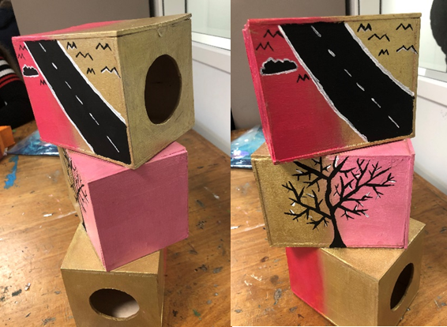
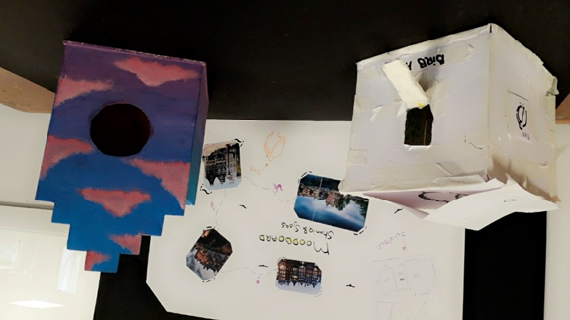
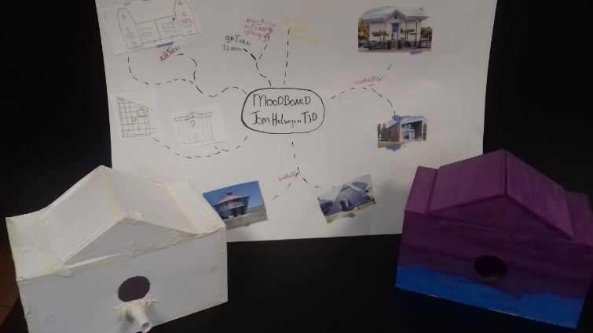
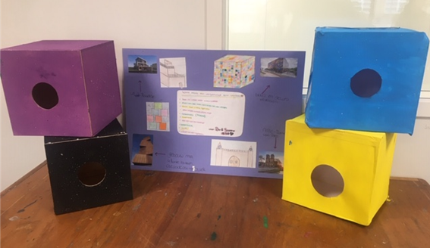
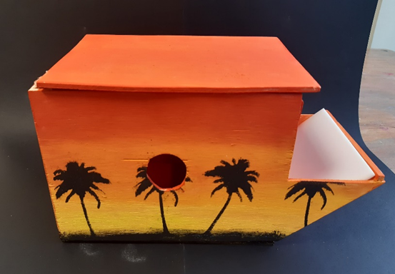
Making birdhouses
Birds nest where there is sufficient food supply and nesting opportunities. Our mostly tidy landscapes, petrified residences and sterile gardens do not offer enough food and natural nesting places. It is therefore important to create as many living options for birds around your house as possible. If there are green spaces, hedges, orchards and streets with high and old trees in the vicinity of your house, then it is important to maintain them in a sustainable way.
The birds which uses birdhouses in the Netherlands are mostly great tits, blue tits, ring sparrows, starlings, house sparrows and some more. They all want specific bird houses. Different distance from the ground, different distance from another birdhouse and a different size of fly hole. Our students started making moodboard to put their ideas on paper and/or get more inspiration. They searched for information on what a good birdhouse has to have. Before making the definite birdhouse out of wood they first made a prototype of paper.

