Erasmus+ project 2018-2020
2018-1-HR01-KA229-047516
Stop Climate Change – Together Europe Achieves More
LESSON PLAN
Subject: Sorting out the rubbish in European countries. Programming in Scratch.
Teacher: Beata Jekiełek, Gdynia, Polska
Time: 45 minutes
Level: pre-intermediate and above
Topic: environmental problems, climate change
Objectives:
- to discuss environmental issues,
- to deal with problems and suggest solutions
- to code the game in Scratch
Key words: environment, global warming, pollution, plastic, glass, paper
Activities: speaking, listening, coding
Outcomes:
Students will be able:
- to understand important causes of environmental problems and some solutions,
- to understand how important it is to sort garbage out
- to program the game about sorting rubbish in their country
Materials needed/resources: projector and 16 tablets/computers
Student grouping: whole class, individual
Literature: - Internet
1. Introduction, 8 minutes
Hello, My name is Beata. I come from Poland. Welcome to my ICT lesson
Today we are going to code in Scratch. All our guests – teachers and students are welcomed to program . The title of our Erasmus+ project is „Stop Climate Change- -Together Europe Achieves More“ so we will talk about enviromental problems and some solutions and finally we will try to code in Scratch a game about sorting out the rubbish
What can we do to stop Climate Change (own ideas):
example:
sort out the rubbish
drive electricity cars
burn trash
Let’s watch a game which we are going to make today.

2 Start to code, 2 minutes
Enter the website www.scratch.mit.edu
click start creating
choose english/click the earth icon
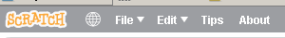
Close the tutorials

3 overview of the program window 2 minutes
On the right hand side of the screen there is a stage with our character – the cat. (In Scratch all the characters are called sprites.)
The sprites will response to our commands.
On the left hand side of the screen there are blocks. We can use them to build a program, in other words – to navigate our sprite.
At the top we can choose different kinds of blocks.
In the middle of the screen there is an area of scripts. You can build all commands there.

4. Characters - sprites 12 minutes
In the bottom right corner of the window
choose a sprite/create
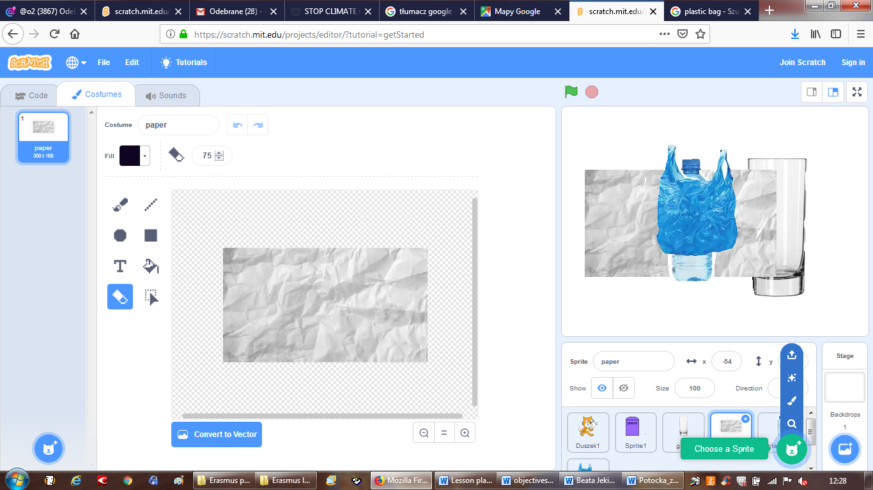
We create/draw containers and we upload the sprites – rubbish.
We have to change the size of rubbish
plastic1, plastic2 – 50
paper – 25
glass - 30
5 Making the Game – 20 minutes
Now we can change the background (called backdrop in Scratch)
First, we have to choose the background of the scenes on the right of the screen. Then we can change backgrounds by choosing a colour and pouring a bucket of paint.
Let’s choose a backdrop from the library. TREE.
Next, we want to put good blocks into sprites in a correct order.
Now we want our sprite to say something. It’s going to look a bit different now, because, in fact, we are not going to use sounds, even though there is such a possibility.
Sprite – cat
Sprite - Start
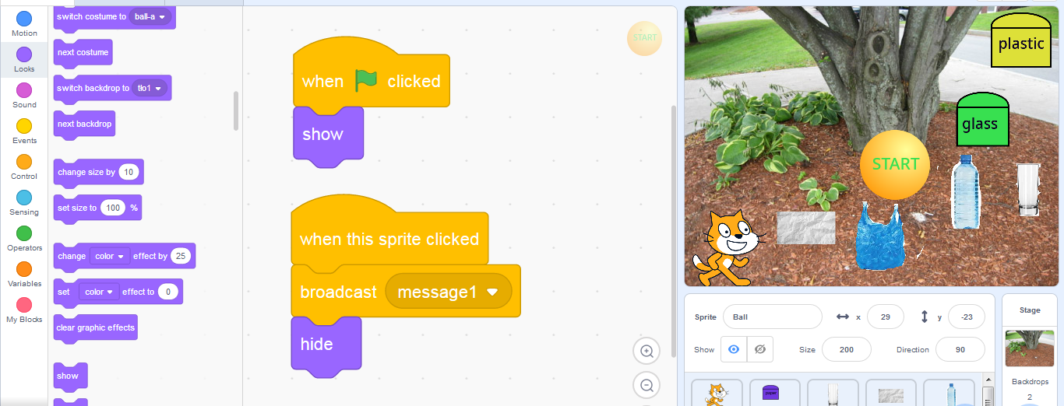

Sprite - containers
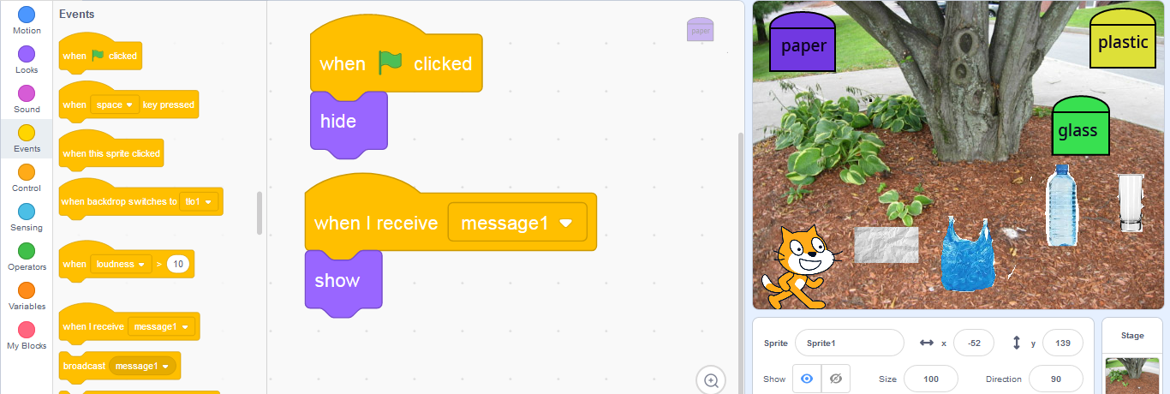

Sprite - rubbish
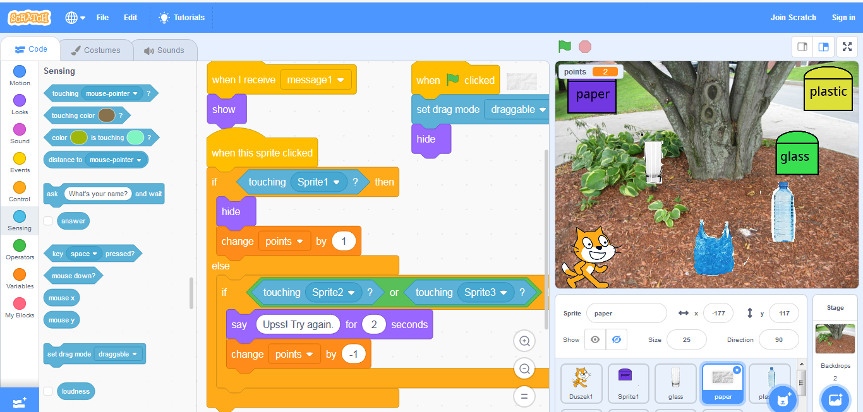
Messages – not each sprite moves at the same time, so to inform another sprite about his move, we can use message broadcasting.
Variable – we wanted it to be a game so we have to give points for good moves or take away points for bad moves.

Now copy our scripts for other containers and rubbish.
Click the right button of the mouse on the script, choose DUPLICATE, and move the copied script to the second sprite.

At the and we save our project:
- choose file and save to your computer
- If you have your own account and log in you can save it there
- You can also join Scratch to save all your work on your account.

6. Summing up, 1 minute
Thank you for your attention and work.
I hope that it was fun for you, and I also hope that we will start changing our habits for a better future of our planet.

