**Erasmus+ project 2018-2020  
2018-1-HR01-KA229- 047516**

**Stop Climate Change – Together Europe Achieves More**

**    
  
LESSON PLAN**  
**Lesson:** *Forests, Fires and Climate Change*

**Teacher:** Giovanna Filomena Palumbo  
**Time:** *45 minutes*  
**Level :** Intermediate

**Key words:** Trees; Forest; Fire; Wildfire; Rainforest; Oxygen; Carbon Dioxide and Monoxide; Global Warming; Biodiversity; Deforestation; Soil Erosion; Lightning; Volcano; Smoke; Forester; Firefighter

**Objectives and goals:**

* Knowledge of the importance and value of trees and forests
* Knowledge of causes and effects of fires
* Promote discussion and reflection about environmental issues
* Suggest solutions

**Outcomes:**

* Students will realise the danger of environmental problems caused by fires and by climate change

**Language skills:** Listening, Reading, Speaking, gap filling and Writing  
**Required materials and equipment :** a PC and a projector, photocopies, pens  
**Student grouping:** small groups (4 students per group)

**Literature:**

* Internet

**Sources for the PowerPoint presentation:**

“The Importance of Trees – Learn Value and Benefit of Trees”

https:// www.savetree.com>whytrees

“Trees importance to our Environment”

[https://www.google.it/url?sa=t&rct=j&q=&esrc=s&source=web&cd=23&ved=2ahUKEwj5gv7V_OPkAhVMDewKHUWBDXgQFjAWegQIBxAB&url=https%3A%2F%2Fwww.1millionwomen.com.au%2Fblog%2Ftrees-importance-to-our environment%2F&usg=AOvVaw3Celcqs1kgOOh3FU52enGY](https://www.google.it/url?sa=t&rct=j&q=&esrc=s&source=web&cd=23&ved=2ahUKEwj5gv7V_OPkAhVMDewKHUWBDXgQFjAWegQIBxAB&url=https%3A%2F%2Fwww.1millionwomen.com.au%2Fblog%2Ftrees-importance-to-our%20environment%2F&usg=AOvVaw3Celcqs1kgOOh3FU52enGY)

“Importance of Forests/ WWF”

“ 21 reasons why forests are important /MNN – Mother Nature... “

<https://www.google.it/url?sa=t&rct=j&q=&esrc=s&source=web&cd=14&cad=rja&uact=8&ved=2ahUKEwi7iv-uheTkAhVCbVAKHQ9RA_gQFjANegQICRAB&url=https%3A%2F%2Fwww.mnn.com%2Fearth-matters%2Fwilderness-resources%2Fblogs%2F21-reasons-why-forests-are-important&usg=AOvVaw22kaX_CZFAOp1WLnBWjuHJ>

“What Causes Forest Fires? – WorldAtlas. Com”

https://www.worldatlas.com>articles>what–causes-forest-fires

“Causes et consequences of forest fires /OMPE/ Organisation...”

<https://www.google.it/url?sa=t&rct=j&q=&esrc=s&source=web&cd=13&cad=rja&uact=8&ved=2ahUKEwiDxZyYlOTkAhUCK1AKHVPuCFgQFjAMegQIAxAB&url=https%3A%2F%2Fwww.ompe.org%2Fen%2Fcauses-et-consequences-of-forest-fires%2F&usg=AOvVaw1LlB4cK95vS_7EZxNoGOhd>

*By Lucy Rodgers, Nassos Stylianou, Clara Guibourg, Mike Hills and Dominic Bailey. Design by Mark Bryson.*

Article about: “The Amazon in Brazil is on fire - how bad is it?- BBC News”

https://www.bbc.com>world-latin-america-49433767

Article: “African forest fires in the spotlight amid outcry over Amazon blazes”

<https://www.google.it/url?sa=t&rct=j&q=&esrc=s&source=web&cd=3&cad=rja&uact=8&ved=2ahUKEwiFzLnAt-fkAhWMLFAKHSDuDl8QFjACegQIDBAH&url=https%3A%2F%2Fwww.france24.com%2Fen%2F20190827-africa-forest-fires-spotlight-outcry-amazon-blazes-congo-basin-macron-g7&usg=AOvVaw3qVAAGtVNPwElAMHJrMPva>

Article: “Maintaining Forests to Prevent Fires”

*The information in this article was taken from a book called Forest Theory, which was written by KKL-JNF's professional staff.

Keren Kayemeth LeIsrael   
Jewish National Fund

www.kkl-jnf.org › forest-maintenance

**Outline**  
 **Introduction** (5 minutes)

1. A short presentation of students and the teacher (name, country, age)

2. Teacher will inform students they will see a PowerPoint presentation about forests and fires, then she will give them out a paper sheet with the following questions:

1. What is a forest?

2. What are the advantages of forests?

3. What causes forest fires?

4. Can you suggest your own solution to prevent forest fires?

**Procedure**

1. Students will answer to the first question and teacher will read to them their answers. Then she will show them a presentation that explains the importance and value of trees and forests, causes and effects of fires and how forest fires contribute to the greenhouse effect and climate change.

(20 minutes)

2. Teacher will ask students to answer to the second and third questions. (5 minutes)

3. After that, teacher will show the last slides of the presentation, concerning some suggestions about the prevention of fire, and she will invite students to give their own suggestions by answering to the last question. (5 minutes)

4. Finally, teacher will give them some exercises to do, working in group. (10 minutes)

The first exercise is a gap filling one.

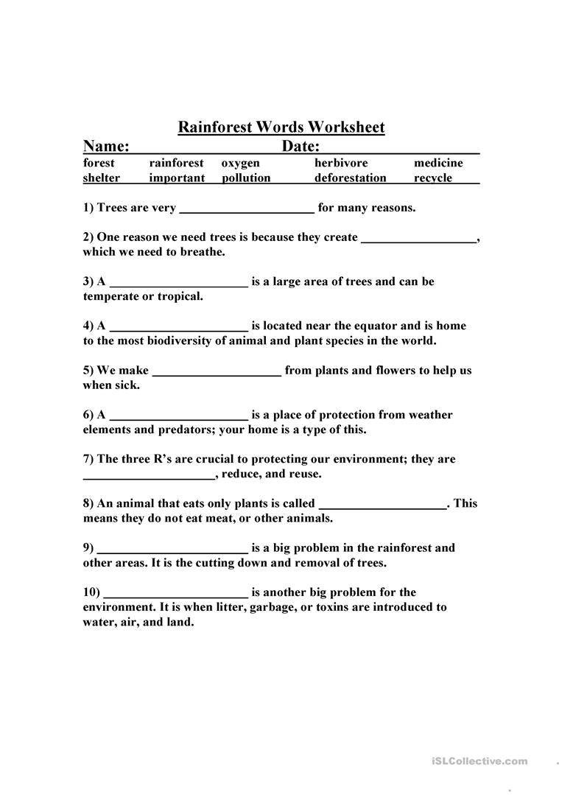

The second exercise is a cloze test.

[CHILE DECLARES FOREST FIRES ALERT – Open Cloze Test](https://avanzado1cristina.wordpress.com/2015/03/27/chile-declares-forest-fires-alert-open-cloze-test/)

Adapted from: <http://www.bbc.com/news/world-latin-america-32045870>