**Erasmus+ project 2018-2020  
2018-1-HR01-KA229- 047516**

**Stop Climate Change – Together Europe Achieves More**

**    
  
LESSON PLAN**  
**Lesson:** *Disasters caused by climate change*

**Teacher:** Giovanna Filomena Palumbo  
**Time:** *45 minutes*  
**Level :** A2/B1

**Key words:** Flood; Drought; Fire; High winds; Storm, Extreme weather, Pollution, Greenhouse effect, Heat, Fossil fuels, Smog

**Objectives and goals:**

* Knowledge of causes and effects of the extreme weather
* Promote discussion and reflection about changing climate risks

**Outcomes:**

* Students will realise the danger of environmental problems caused by climate change

**Language skills:** Listening, Reading, Speaking, gap filling and Writing  
**Required materials and equipment :** a PC and a projector, photocopies, pens  
**Student grouping:** small groups (4 students per group)

**Literature:**

* Internet
* [www.teachingenglish.org.uk](http://www.teachingenglish.org.uk)

**Outline**  
 **Introduction** (8-10 minutes)

1. A short presentation of students and the teacher (name, country, age)

2. Teacher will inform students they will see a file with some pictures about environmental disasters occurred in Italy last year.

Disasters caused by climate change in Italy

FLOOD

[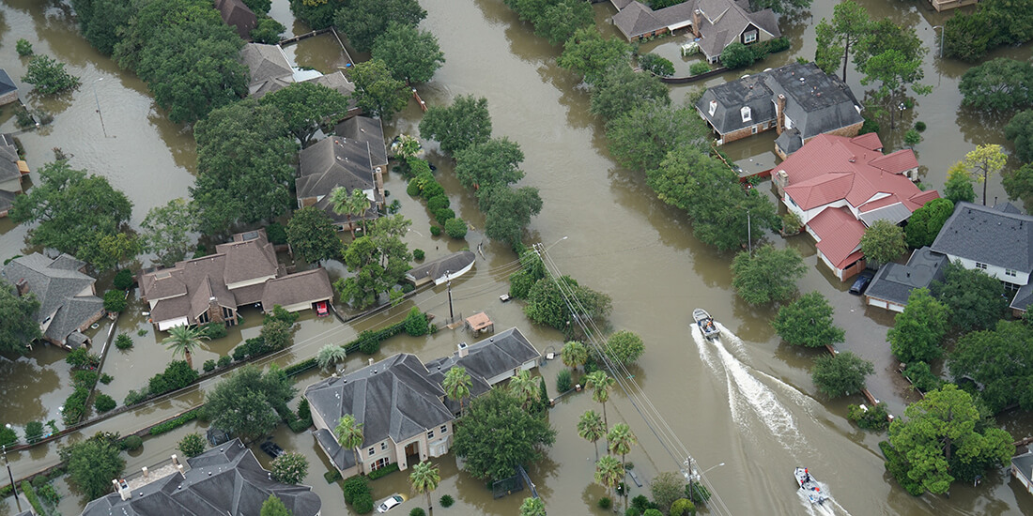](https://www.google.it/url?sa=i&rct=j&q=&esrc=s&source=images&cd=&cad=rja&uact=8&ved=2ahUKEwjXmISh6uPgAhVMZlAKHXvpBHQQjRx6BAgBEAU&url=https://www.autodesk.com/redshift/climate-change-and-natural-disasters/&psig=AOvVaw3oNK_zAlqIPOasVwYhRDVx&ust=1551628898530432)

DROUGHT

[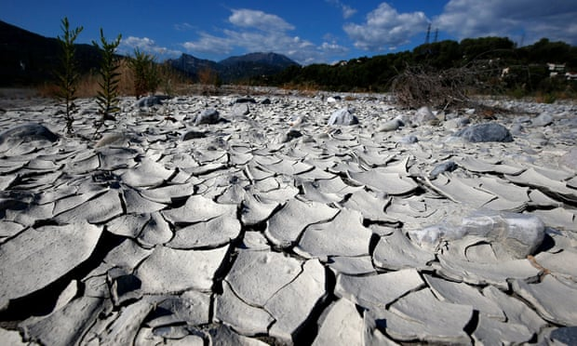](https://www.theguardian.com/environment/2017/jan/25/europe-faces-droughts-floods-storms-climate-change-accelerates#img-1)

FIRE

[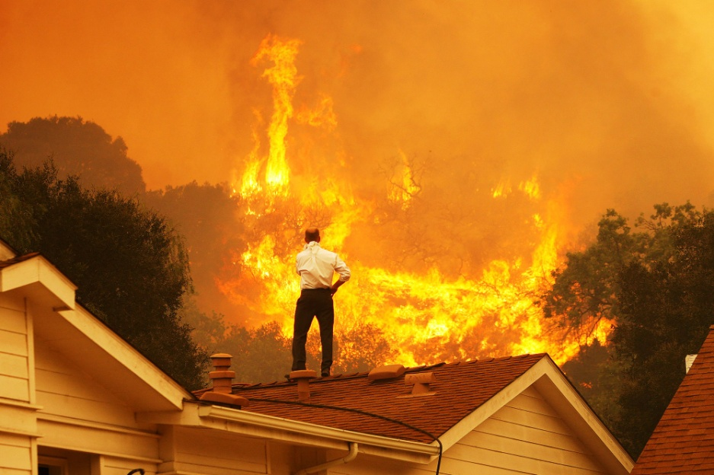](https://www.google.it/url?sa=i&rct=j&q=&esrc=s&source=images&cd=&ved=2ahUKEwjQvsXD6-PgAhWFalAKHcGBD34QjRx6BAgBEAU&url=https://www.gq.com/story/billionaires-climate-change&psig=AOvVaw3oNK_zAlqIPOasVwYhRDVx&ust=1551628898530432)

HIGH WINDS, DOLOMITES NOVEMBER 2018

[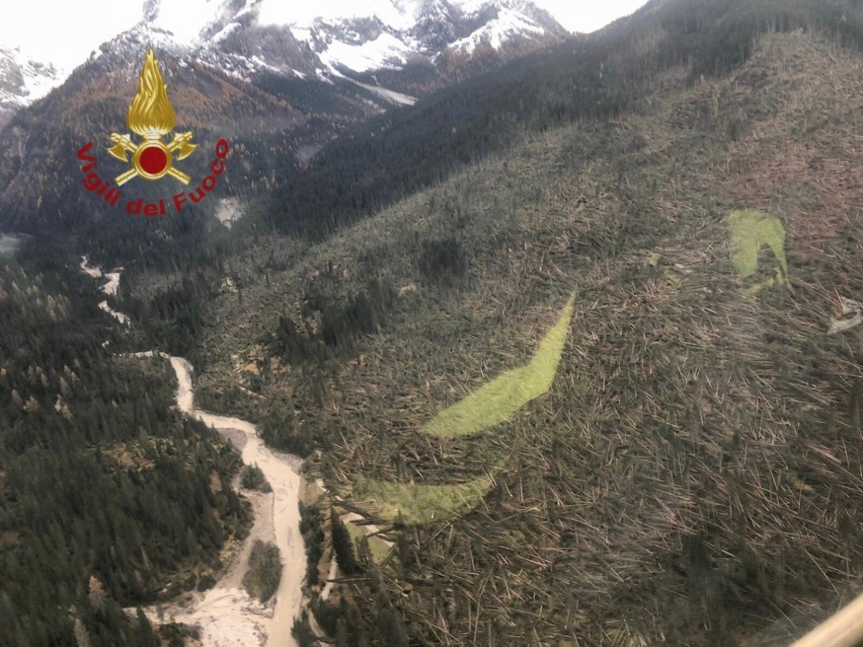](http://www.google.it/url?sa=i&rct=j&q=&esrc=s&source=images&cd=&cad=rja&uact=8&ved=2ahUKEwjOt_Lp7OPgAhWLL1AKHcnuCaEQjRx6BAgBEAU&url=http://www.the-ski-guru.com/2018/11/02/storm-wreak-havoc-italy-killing-10-situation-trentino-alto-adige-belluno/&psig=AOvVaw27mH5f8oEpZ_Mv-isfi563&ust=1551629588512413)

STORM IN LIGURIA

[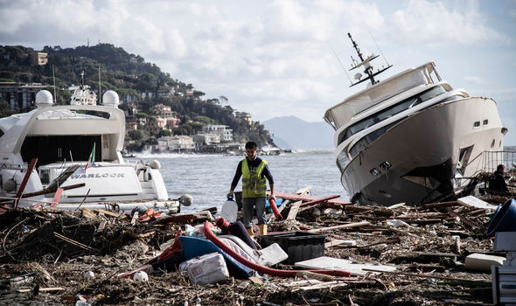](https://www.google.it/url?sa=i&rct=j&q=&esrc=s&source=images&cd=&cad=rja&uact=8&ved=2ahUKEwjn_8Gn8OPgAhVRZlAKHWYvB_MQjRx6BAgBEAU&url=https://www.express.co.uk/news/world/1039149/italy-weather-venice-liguaria-flood-storm-rome-orange-alert-latest&psig=AOvVaw2CpRiBZmWef851RTKy7OCz&ust=1551629897689603)

3. Teacher will ask some questions about climate change:

* What are the causes of climate change?
* What are the impact of climate change?
* What can we do about it?

After a brief discussion, teacher will inform students that they will watch the video 🙶Causes and Effects of Climate Change🙷 (National Geographic – 3.05 minutes) twice.

<https://www.youtube.com/watch?v=G4H1N_yXBiA>

**Procedure** (35 minutes)

Working in group, students will do exercises about climate change, taken

from British Council – TeachingEnglish/Lesson plans – Climate change

worksheets 93k pdf

([www.teachingenglish.org.uk](http://www.teachingenglish.org.uk))

**Worksheet A – Climate change – the evidence**

**Worksheet B – How green are you?**

**Worksheet C – Recycling Race**

**Worksheet D – Global warming message board**

**Worksheet E – Climate change – Discussion Statements**