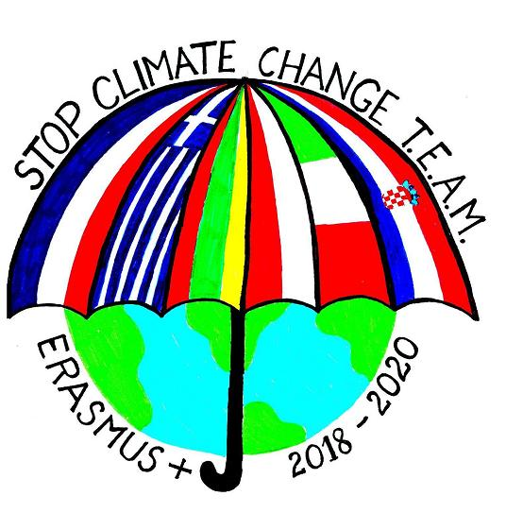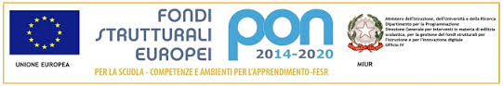 

ISTITUTO COMPRENSIVO DI SANT' ELIA A PIANISI

Erasmus Plus " Stop Climate Change -Together Europe achieves more"  
Activities for Dissemination

Teachers and students decided to stick two Erasmus-themed panels to the lower secondary school entrance, to make the whole population aware of the presence of the project in our school.

The third panel is about CULTURE, to emphasize its importance and the fact that only culture makes FREE!

