Erasmus+
Stop Climate Change-Together Europe Achieves More

First meeting

Friday 14 September

The first meeting of the new Erasmus program took place at auditorium of 1st Gymnasium of Cholargos. Teachers of Erasmus team informed the students interested in participating in this project.

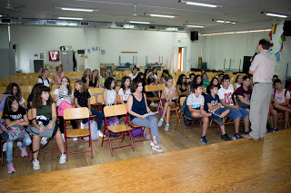

The headmaster of the school, Mr. Sotiris Pantos κ. Πάντο and the coordinator of the Greek school, Mrs. Christina Bravou talked about the aims and activities of this project. A short video also projected about climate change.

